Title: Classifying the conditions to predict different drop breakup regimes.

Introduction: Surfactants, or surface-active agents, can significantly alter interfacial evolution and flow in a  
two-phase fluid mixture by changing the surface tension. The shape of a drop centered in an axisymmetric extensional flow is determined by the viscous stresses that deform the drop and surface tension that resists the deformation. The ratio of these stresses is given by the capillary number, Ca. When Ca is small enough, the drop attains a steady shape. However, above a threshold value, called the critical capillary number, the drop elongates continuously, and no steady shape is attained. When surfactants are present on the drop interface, the surface tension is determined by the surface concentration profile, which varies throughout the deformation process. A notable effect of the presence of surfactants is the phenomenon of tipstreaming, in which a thin thread and small droplets are emitted from the tip of a drop or bubble that is stretched in an extensional flow. This occurs due to uneven distribution of surfactants on the surface.

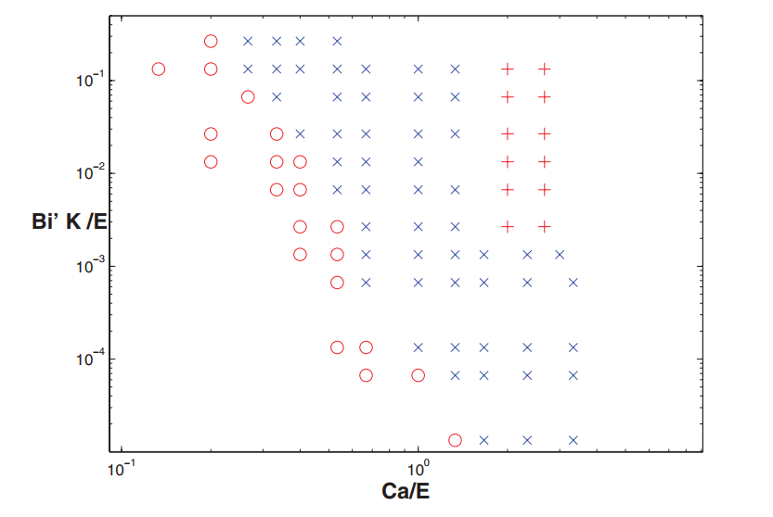The objective of the work is to identify the regime that leads to the tip-streaming phenomena. The major variables include the Capillary number (representative the flow condition), the ratio of fluid viscosities, the partition coefficient K (rate of adsorption to desorption at the interface) and the Biot number which defines the amount of surfactant adsorbed on the interface from the bulk fluid media. As part of this report, the data from the work of Wang and Booty (2014) is being used for a given viscosity ratio. Figure 1 shows the plot from which the data used is drawn. Here the red “o” represents steady shapes while the blue “x” defines the regime that leads to tip-streaming and red “+” represents breakup regime. The product of modified Biot Number (constant here) and partition Coefficient (K) is plotted with changing flow regimes defined using the Capillary number. Both are divided by the medium elasticity, E (a constant for given drop and medium fluids). While only two variables have been used in the present work, the aim is to include the third variable i.e. the viscosity ratio and Biot number as the fourth variable. This will be performed as part of my thesis later in the program.

Figure 1. Conditions for tipstreaming and other breakup modes in terms of the partition coefficient and capillary number.

**Methods:** The analysis is about defining a model that can predict the regimes for tip-streaming. Towards this objective, the three breakup regimes i.e. steady state (red “o”), tip-streaming (blue “x”) and breakup regime (red “+”) were classified as values 1, 2 and 3.

Model Fitting: A 3D model was drawn to model these regimes.

Model Diagnostics: The model diagnostics were performed for the given model.

PCA analysis: Principal Component Analysis was performed on the data.

kNN Classification: This was applied to classify the data into the three different regimes.